. The School Year (SY) 2018-2019 shall formally open on Monday, June 4, 2018 and shall end on Friday, April 5, 2019. It shall consist of 208 school days inclusive of the five-day In-Service Training and the three days for the Parent-Teacher Conferences (PTC) conducted within the school year. However, learners are expected to be in school for a total of 200 class days as shown in Enclosure No. 2.

2. Private schools may deviate from this School Calendar. However, they may not start classes earlier than the first Monday of June and not later than the last day of August, as provided in Republic Act (RA) No. 7797, entitled An Act to Lengthen the School Calendar from Two Hundred (200) Days to Not More than Two Hundred Twenty (220) Class Days. Said schools should notify in advance their respective regional offices (ROs) regarding any deviation from the school calendar.

3. The Implementing Guidelines on the SY 2018-2019 Calendar of Activities are provided in Enclosure No. 1 to enable the schools to effectively and efficiently implement the school events and activities. Likewise, the guidelines shall allow the ROs and the schools division offices to provide support to schools, particularly in the areas of instruction, and progress monitoring and evaluation.

4. Schools may observe national and local celebrations/activities and holidays other than those indicated in Enclosure Nos. 2 and 3, provided that the activities are beneficial to the teaching-learning process, and that the total number of class days shall not be compromised.

5. Make-up classes are recommended in lieu of class cancellations due to celebrations and holidays, as well as natural and man-made calamities. Mechanism for the conduct of make-up classes must be agreed upon by school heads and the Parent-Teacher Associations. In this regard, the ROs may issue a regional school calendar to announce and reflect their concerned events.

6. Immediate dissemination of and strict compliance with this Order is directed.

**LEONOR MAGTOLIS BRIONES**  
Secretary

**(Enclosure No. 1 to DepEd Order No. 25, s. 2018)**

IMPLEMENTING GUIDELINES ON THE SCHOOL CALENDAR FOR SCHOOL YEAR (SY) 2018-2019

1. The school year (SY) shall formally open on Monday, June 4, 2018 and shall end on Friday, April 5, 2019. It shall consist of 208 school days inclusive of the five-day In-Service Training and three days of Parent-Teacher Conferences (PTC).

2. Learners are expected to be in school for a total of 200 class days for this SY. To ensure quality in the school operation and actual teaching learning, the 187-day contact time for teachers and learners is non-negotiable. The physical presence of school heads in schools shall also be enforced.

3. Local activities and observances that involve student participation, such as competitions, festivities, press conferences, culminating activities, and field demonstrations must be regulated so as not to cause disruption of classes and to ensure that the required contact time or number of teaching-learning days is met. Regions, Divisions and Schools are encouraged to plan and implement these activities once in a school year or after each quarter. There shall be no co-curricular and extra-curricular activities two weeks before the quarterly examinations.

4. A general assembly shall be conducted by all schools to orient stakeholders on the curriculum, co-curricular programs and ancillary services to support learner development and the continuous improvement of school outcomes. The assembly shall be done at least a week before the school opening to ensure that the conduct of classes is done on the formal opening of classes on June 4.

5. Parent-teacher conferences shall be done to apprise the parents on the performance of their children and ensure their involvement in school activities. These conferences shall be conducted back-to-back with the General Assembly and every second Saturday after the Quarterly Examinations except on the last conference in April 2019.

6. All elementary schools shall administer the Philippine Early Childhood Development (ECD) Checklist for Kindergarten Children during the opening of classes, midyear, and end of school year. The result will be used as basis for planning and formulating appropriate interventions for children.

7. Deworming of children in school shall be conducted within the months of July 2018 and January 2019.

8. A career guidance program shall be conducted between July and November 2018 to guide Grades 9 and 10 students in making informed choices on their preferred Senior High School track.

9. At the end of the Second Quarter, a semestral break for learners shall be observed to evaluate individual teachers and their collective performance, to conduct the In-Service Training (INSET) activities, and to prepare their Instructional Materials (IMs) for their continuing professional development.

10. The Christmas break shall begin on Saturday, December 22, 2018. Classes shall resume on Wednesday, January 2, 2019.

11. To assure quality of learning, formative assessments shall be regularly conducted by the teachers. On the national level, the Bureau of Education Assessment (BEA) shall administer the National Career Assessment Examination (NCAE) to assess the aptitude and interest of students and provide them with relevant information on their skills, abilities, and readiness for academic and non-academic courses, the Early Language Literacy and Numeracy Assessment (ELLNA) to measure the literacy skills of the learners in their respective Mother Tongues, Filipino and English and the National Achievement Test (NAT) to measure what learners in Grade 6 and Grade 10 know and can do in five learning areas.

The summer/remedial classes shall begin on Monday, April 15, 2019 and end on Friday, May 24, 2019.

12. Learner deliberation may be conducted two weeks before the graduation or moving up ceremonies for the following:

MORE FROM TEACHERPH

[DEPED ORDER](https://www.teacherph.com/category/issuances/deped-order/)

[Early Language Literacy and Numeracy Program Funds](https://www.teacherph.com/early-language-literacy-and-numeracy-program-funds/)

May 23, 2018

[DEPED ORDER](https://www.teacherph.com/category/issuances/deped-order/)

[Promotion and Compensation of all ALS Implementers](https://www.teacherph.com/promotion-compensation-als-implementers/)

May 18, 2018

[DEPED ORDER](https://www.teacherph.com/category/issuances/deped-order/)

[Flexible Working Hours of DepEd Non-Teaching Personnel](https://www.teacherph.com/deped-non-teaching-personnel-working-hours/)

May 11, 2018

[DEPED ORDER](https://www.teacherph.com/category/issuances/deped-order/)

[School Readiness Year-End Assessment (SReYA)](https://www.teacherph.com/school-readiness-year-end-assessment-sreya/)

May 11, 2018

a. Learners who will receive recognition and awards; and

b. Learners who are candidates for graduation. They shall accomplish their clearance on the week prior to date of graduation.

13. In preparation for the opening of classes for SY 2019-2020, the schools shall conduct the following activities:

a. Early Registration of learners, beginning on Saturday, January 26, 2019 in the schools where they wish to study;

b. Brigada Eskwela from May 13 to 17, 2019 to enable the community and the school to prepare their facilities before the start of another school year;

c. Oplan Balik Eskwela from May 20 to May 31, 2019 to facilitate the enrolment of learners; and

d. In-Service Training (INSET) activities for teachers from May 27 to May 31, 2019, a week before the opening of classes.

14. In Enclosure No. 2, a calendar is presented with specific markings:

a. Declared holidays and weekdays with no classes are crossed out (X).

b. Days with school activities for teachers, personnel and other stakeholders (e.g. PTC, general assemblies, PEPT for out-of-school learners) are boxed (□).

c. Days with student activities or activities that involve student participation (e.g. NFOT, NSPC, deworming of school children) are encircled (O). These activities are conducted on class days and may or may not disrupt classes. If the date for a student activity in a specific month is still tentative, the last school day may be temporarily marked as alternate day for said activity.

d. School activities conducted for several weeks (i.e. Early Registration) are no longer reflected in the actual calendar.

DepEd School Calendar for School Year (SY) 2018-2019

**Enclosure No. 2 to DepEd Order No. 25, s. 2018**

| **Month** | **Activity** | **No. of School Days** |
| --- | --- | --- |
| **May 2018** |  |  |
| May 21-June 8 | Oplan Balik Eskwela |  |
| May 21-June 2 | Brigada Eskwela |  |
| **June 2018** |  |  |
| 2 | 1st General Assembly and Parent-Teacher Conference (Sat.) | **First Quarter: 48 days** |
| 4 | Beginning of classes |  |
| 12 | Independence Day (regular holiday) |  |
| 15 | Eid’l Fitr (regular holiday) |  |
| Tentative | Early Language Literacy and Numeracy Assessment (ELLNA) |  |
| Tentative | Special Philippine Educational Placement Test (PEPT for Independence Day) |  |
| **July 2018** |  |  |
| 2-31 | Deworming of School Children |  |
| **August 2018** |  |  |
| 9-10 | First Quarter Examinations |  |
| 18 | Distribution of Report Cards and 2nd Parent-Teacher Conference | **2nd Quarter: 48 days** |
| 21 | Ninoy Aquino Day (special nonworking holiday) |  |
| 22 | Eid’l Adha (regular holiday) |  |
| 27 | National Heroes Day (regular holiday) |  |
| Tentative | National Career Assessment Examination for Grade 9 |  |
| **September 2018** |  |  |
| **October 2018** |  |  |
| 5 | World Teachers’ Day |  |
| 18-19 | Second Quarter Examinations |  |
| 22 | Start of Sembreak | **3rd Quarter: 52 days** |
| 22-26 | In-Service Training for Teachers |  |
| 27 | Distribution of Report Cards and 3rd Parent-Teacher Conference |  |
| 29 | Resumption of Classes |  |
| Tentative | Accreditation and Equivalency Test (A&E) |  |
| **November 2018** |  |  |
| 1 | All Saints Day (special non-working holiday) |  |
| 2 | All Souls Day (special non-working holiday) |  |
| Tentative | Administration of PEPT (regular) |  |
| Tentative | Basic Education Exit Assessment for Grade 12 |  |
| 30 | Bonifacio Day (regular holiday) |  |
| **December 2018** |  |  |
| 15 | Class Day |  |
| 22 | Start of Christmas Break |  |
| 30 | Rizal Day (regular holiday) |  |
| Tentative | National Musabaqah |  |
| **January 2019** |  |  |
| Entire Month | Deworming of school children |  |
| 2 | Resumption of classes |  |
| 10-11 | Third Quarter Examinations |  |
| 19 | Distribution of Cards (Parent -Teacher) Conference | **4th Quarter: 60 days** |
| Jan. 26 -Feb. 27 | Early Registration for Kindergarten to Grade 12 |  |
| Jan. 28-Feb. 1 | National School Press Conference (NSPC)  National Festival of Talents (NFOT) |  |
| **February 2019** |  |  |
| 4-15 | Supreme-Pupil Government/Supreme -Student Government Election (First to Second Week) |  |
| 5 | Chinese Lunar New Year’s Day (Special non-working holiday) |  |
| **March 2019** |  |  |
| 14-15 | Fourth Quarter Examinations for Grades 6 and 12 |  |
| 21-22 | Fourth Quarter for Grades 1-5 & 7-11 |  |
| Tentative | National Achievement Test (NAT) for Grade 6 and 10 |  |
| **April 2019** |  |  |
| 1-5 | End of School Year Rites |  |
| 5 | Last Day of Classes for SY 2018-2019 |  |
| 9 | Araw ng Kagitingan (regular holiday) |  |
| 11-12 | Distribution of Report Cards and 5th Parent-Teacher Conference |  |
| 15 | Start of Summer Classes |  |
| 18-19 | Maundy Thursday and Good Friday |  |
| Tentative | Palarong Pambansa |  |
| **May 2019** |  |  |
| 1 | Labor Day (regular holiday) |  |
| Tentative | Brigada Eskwela |  |
| Tentative | Oplan Balik Eskwela |  |
| 24 | End of Summer Classes |  |
|  | **Total Number of School Days** | **208** |
|  | **Total Number of Class Days** | **200** |

Download DepEd Order No. 25, s. 2018 (DepEd School Calendar for School Year 2018-2019)

[Join Our Facebook Discussion Group – Click Here](https://www.facebook.com/groups/teacherph/" \t "_blank)

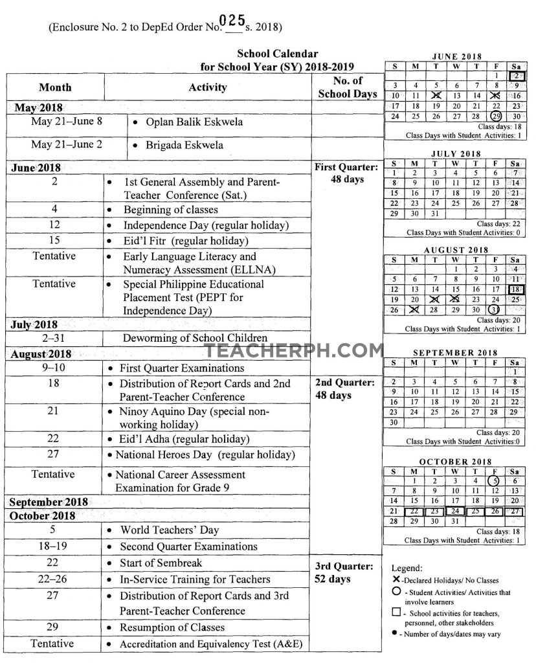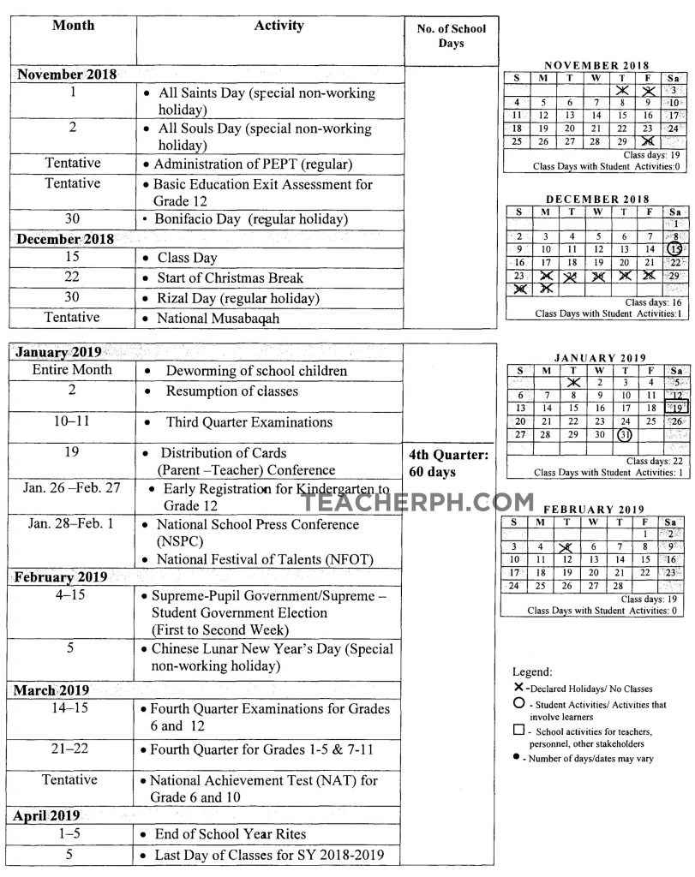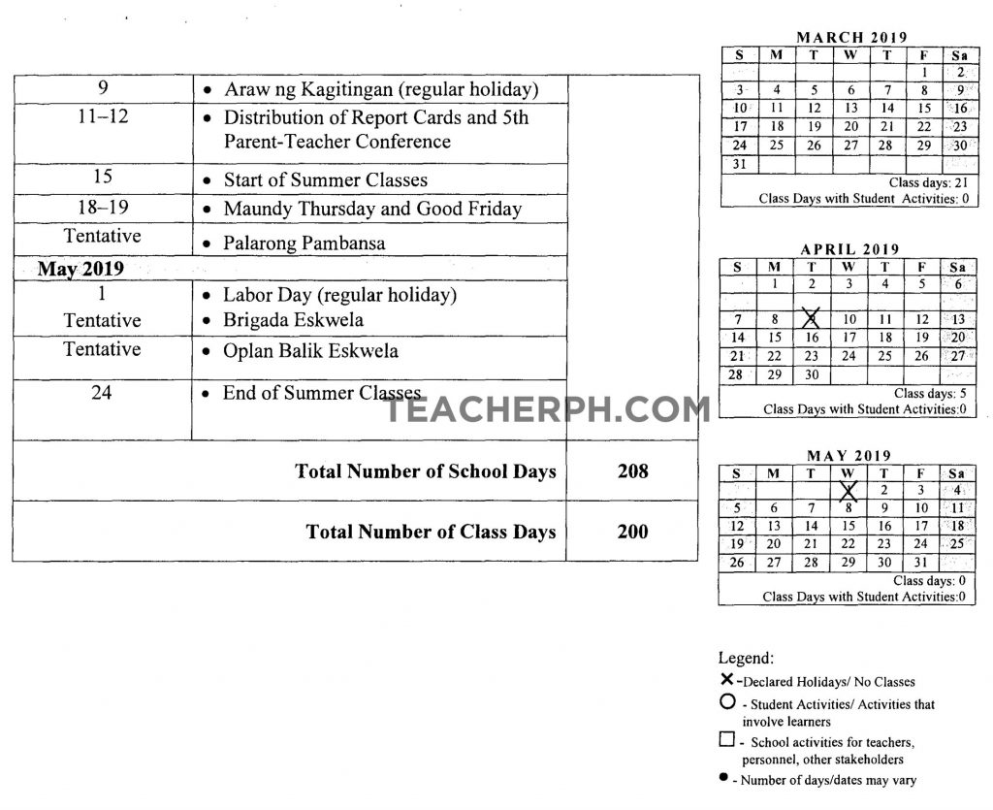

Activities and/or Observances Mandated by Law

**Enclosure No. 3 to DepEd Order No. 25, s. 2018**

| **Month/Date** | **Activities and/or Observances** | **Legal Bases** |
| --- | --- | --- |
|  |  |  |
| **MAY** |  |  |
| 9 | Commemoration of the Birth Anniversary of Horacio Dela Costa | Administrative Order (AO) No. 23, 2011 |
| 10 | Commemoration of the Death Anniversary of Andres Bonifacio |  |
| 13 | Commemoration of the Death Anniversary of Apolinario Mabini |  |
| 22 | Commemoration of the Philippine-Australia Friendship Day |  |
| 26 | Commemoration of the Birth Anniversary of Felipe Agoncillo |  |
| May 28- June 12 | National Flag Day Celebration | Republic Act (RA] No. 8491 Presidential Proclamation (PP) No. 374, s. 1965  Executive Order (EO) No. 179, s. 1994 |
| **JUNE** |  |  |
| 1-30 | Dengue Awareness Month | Health Calendar 2016 (DOH) |
|  | National Kidney Month |  |
| 5 | World Environment Day | DM No. 14, s. 2014 |
| 13-17 Third week of June | National Safe Kids Week | PP 1307, s. 2007 |
| 14 | World Blood Donor Day | Health Calendar 2016 (DOH) |
| June 16-Dec 31 | Nationwide Search for the Outstanding W.A.T.C.H. (We Advocate Time Consciousness and HonestyJ Schools | PP 1782,s. 2009 |
| June 16-Dec 31 | Pambansang Gawad sa Ulirang Kabataan | PP110, s. 1963 PP 28, s. 1962 DM 146 s, 2014 |
| 19 | Commemoration of the Birth Anniversary of Dr. Jose Rizal | AO 23, s. 2011 |
| 24 | Commemoration of the Birth Anniversary of Marcela Agoncillo |  |
| 25 | Commemoration of the Birth Anniversary of Galicano Apacible | AO 23, s. 2011 DM 146, s. 2014 |
| 26 | International Day Against Drug Abuse | Health Calendar 2016 (DOH) |
| 30 | Commemoration of the Historic Siege of Baler and Philippine-Spanish Friendship Day | RA 9187 PP 1696, s. 2008 |
| **JULY** |  |  |
| 1-31 | National Disaster and Preparedness Month | DM 69, s. 2015 EO 137, s. 1999 |
|  | National Nutrition Month | PP 491, s. 1974 |
|  |  | DM 62, s. 2015 |
| 4 | Commemoration of the Death Anniversary of Marcelo H. Del Pilar | AO 23, s. 2011 |
| 7-11 | Science and Technology Week | DM308, s. 2008 |
| 12 | Commemoration of the Birth Anniversary of Vicente Abad Santos | AO 23, s. 2011 |
| 17-23 | National Disability Prevention and Rehabilitation Week | PP 361, s. 2000 PP 1870, s. 1979 PP 361, s. 2000 |
| 22 | Commemoration of the Birth Anniversary of Apolinario Dela Cruz fHermano Puli] | AO 23, s. 2011 |
| 23 | Commemoration of the Birth Anniversary of Apolinario Mabini | RA 9430 AO 33, s. 2012 DM 130, s. 2013 PP 361, s. 2000 |
| 23 | Commemoration of the Philippine-Japan Friendship Day | AO 23, s. 2011 |
| 24-28 | Career Guidance Week | DO 25, s. 2013 |
| Last Week | Linggo ng Musikang Pilipino | PP 933, s. 2014 |
| **AUGUST** |  |  |
| 1-31 | Buwan ng Wikang Pambansa | Proklamasyon Big. 1041, s. 1997 DM 24, s. 2016 |
|  | History Month | PP 339, s. 2012 |
|  | National Adolescent Immunization Month | Health Calendar 2016 (DOH) |
|  | National Breastfeeding Awareness Month |  |
|  | National Tuberculosis Awareness Month |  |
|  | Sight Saving Month | PP 40, s. 1954 |
| 1 | Commemoration of the Death Anniversary of President Manuel L. Quezon | AO 23, s. 2011 |
| 7-13 | ASEAN Week | PP 1008, s. 2007 DM 143, s. 2013 |
| 9 | National Indigenous People's Day | RA 10689 |
| 19 | Commemoration of the Birth Anniversary of Manuel L. Quezon | RA 6741 DM 127, s. 2013 |
| 30 | Commemoration of the Birth Anniversary of Marcelo H. Del Pilar | AO 23, s. 2011 |
| 30 | Commemoration of the Anniversary of the Battle of San Juan Del Monte |  |
| 31 | Commemoration of the Birth Anniversary of President Ramon Magsaysay |  |
|  | White Cane Safety Day | RA 6759 DM 77, s. 2015 |
| **SEPTEMBER** |  |  |
| 1-30 | National Peace Consciousness Month | PP 675, s. 2004 |
| 1-7 | National Crime Prevention Week | PP 461, s. 1994 DM 158, s. 2013 |
| September 5-October 5 | National Teacher's Month | PP 242, s. 2011 DM 99, s. 2015 |
| Second week | National Suicide Prevention Day | Health Calendar 2016 (DOH) |
| 15 | Commemoration of the Opening of Malolos Congress | PP 246, s. 2011 |
| 21 | Commemoration of the Anniversary of the Declaration of Martial Law | AO 30, s. 2012 PP 1081, s. 1972 |
| 25-30 | Linggo ng Kabataan | PP 99, s. 1992 |
| 26-30 | Linggo ng Kasuotang Filipino | PP 675, s. 2005 DM 179, s. 2013 |
| 27 | Commemoration of the Birth Anniversary of Gen. Miguel Malvar | AO 23, s. 2011 DM 146, s. 2014 |
| 28 | Commemoration of the Birth Anniversary of President Diosdado Macapagal | AO 23, s. 2011 |
| Last week of September | Family Week | PP 60 s. 1992 |
| **OCTOBER** |  |  |
| 1-31 | Consumers Welfare Month | PP 1098, s. 1997 DM111, s. 2015 |
|  | National Health Month | DM 174, s. 2012 |
|  | National Indigenous Peoples (IP) Month | PP 1906, s. 2009 |
| 1-7 | Elderly Filipino Week | PP 470, s. 1994 |
| 5 | World Teachers' Day | RA 10743 |
|  |  | DM 99, s. 2015 |
|  |  | DM32, s. 2016 |
| 6 | Global Hand Washing Day | DM 119, s. 2015 |
| 17-20 | Commemoration of the Leyte Gulf Landing | PP 653, s. 1995 AO 108, s. 1994 |
| 20 | Commemoration of the Birth Anniversary of Artemio Ricarte | AO 23, s. 2011 |
| 24 | Commemoration of the Birth Anniversary of Juan Luna |  |
| 25 | Commemoration of the Birth Anniversary of Leon Apacible |  |
| 29 | Commemoration of the Birth Anniversary of Antonio Luna |  |
| (tentative) | Juvenile Justice and Welfare Consciousness Week | PP 489, s. 2012 DM122, s. 2015 |
| tentative) \* 3rd week of June | National Health Education Week | DM174, s. 2012 |
| **NOVEMBER** |  |  |
| 1-30 | Filipino Values Month | PP 479, s. 1994 |
|  | Malaria Awareness Month | PP 1168, s. 2006 |
|  |  | RA 10661 |
|  |  | DM 63, s. 2015 |
|  |  | DM 124, s. 2015 |
|  | National Environment Awareness Month | RA 9512 DM 14, s. 2014 |
|  | National Reading Month | DM 145, s. 2012 |
| 7-10 | National Observance of Deaf Awareness Week | PP 829, s. 1991 DM176, s. 2012 |
| 16 | Commemoration of the Birth Anniversary of President Elpidio Quirino | PP 967, s. 2015 |
| 25 | National Consciousness Day for the Elimination of Violence Against Women and Children fVAWC) | RA10398 |
| Nov 25-Dec 12 | 18-Day Campaign to End Violence Against Women fVAW) |  |
| 27 | Araw nq Paqbasa | RA 10556 |
| 25-29 Fourth week | National Week for the Gifted and Talented | PP 199, s. 1999 |
| Last week | National Music Week for Young Artists | PP 25, s. 1998 DM20, s. 2014 |
| **DECEMBER** |  |  |
| 1-31 | Firecrackers Injury Prevention Month | Health Calendar 2016 (DOH) |
|  | Rizal Month | PP 126, s. 2001 |
| 1 | World AIDS day | DM 270, s. 2011 |
| 3 | International Day of Persons with Disabilities | PD 1157, s. 2006 |
| 4-10 | National Human Rights Consciousness Week | RA 9201 DM152, s. 2015 |
| 11 Second Sunday | National Children's Day of Broadcasting | RA 8296 |
| 7-12 | Education Week | PP 2399, s. 1985 |
| (tentative) | Historical, Cultural and Arts Festival of Excellence | PP 126, s. 2001 |
| **JANUARY** |  |  |
| 1-31 | Food Conservation Month | PP1398, s. 1975 |
|  | Physical Fitness and Sports Development Month | EO 63, s. 1993 |
|  | Zero Waste Month | Health Calendar 2016 (DOH) |
| 18-24 | National Cancer Consciousness Week | PP 1348, s. 1975 |
| 20-27 | National Autism Consciousness Week | PP 711, s. 1996 DM 5, s. 2016 |
| 23 | Commemoration of the Anniversary of the Inauguration of the First Philippine Republic | PP 533, s. 2013 PP 523, s. 2012 |
| **FEBRUARY** |  |  |
| 1-28 | National Arts Month | PP 683, s. 1991 DM25, s. 2016 |
|  | National Dental Health Month | PP 559, s. 2004 DM 7, s. 2013 |
|  | National Heart Month | PP 1096, s. 1973 |
| 4 | Commemoration of the Death Anniversary of Baldomero Aguinaldo | AO 23 |
| 6 | Commemoration of the Death Anniversary of General Emilio Aguinaldo |  |
| 7 | Adoption Consciousness Celebration | PP 72, s. 1999 |
| 12-18 | Leprosy Control Week | PP 467, s. 1965 |
| 13-17 | National Awareness Week for the Prevention of Child Sexual Abuse and Exploitation | PP 731, s. 1996 DM 5, s. 2015 |
| 14-20 | National Children with Intellectual Disabilities Week | PP 1385, s. 1975 |
| 17 | Commemoration of the Anniversary of the Martyrdom of GOMBURZA | PP 204, s. 2002 |
| 22-25 | EDSA People Power Anniversary | AO 47, s. 2002 PP 1224, s. 2007 PP 1105, s. 2015 |
| 26 | Commemoration of the Birth Anniversary of Baldomero Aguinaldo | AO 23, s. 2011 |
| 29 | Reinterment of Remains of Elpidio Quirino |  |
| **MARCH** |  |  |
| 1-31 | Fire Prevention Month | PP 115-A, s. 1966 |
|  | National Women's Month | RA 6949 |
|  |  | PP 224, s. 1988 |
|  |  | PP 227, s. 1988 |
|  |  | DM 28, s.2014 |
| 7 | Girl Child Week | PP 759, s. 1996 |
|  |  | DM 110, s. 1999 |
| 9 | Commemoration of the Birth Anniversary of Paciano Rizal | PP 1737, s. 2009 |
| 17 | Commemoration of the Death Anniversary of President Ramon Magsaysay | AO 23, s. 2011 |
| 22 | Commemoration of the Birth Anniversary of General Emilio Aguinaldo |  |
| (tentative] | Global Money Week | DM91, s. 2015 |
| **APRIL** |  |  |
| 2 | Commemoration of the Birth Anniversary of Francisco "Balagtas" Baltazar | PP 964, s. 1997 DM 13, s.2014 |
| 10 | Commemoration of the Birth Anniversary of General Isidoro Torres | AO 23, s. 2011 |
| 5-11 | Commemoration of the Araw ng Kagitingan and Philippine Veterans Week |  |

**Old Update May 16, 2018:**

Mandated by RA 7797 to lengthen the school calendar from 200 days to not more than 220 class days, the number of school days for SY 2018-2019 is set to be 205. Classes shall begin on the first Monday of June.

For SY 2018-2019, DepEd requires all public and private elementary and secondary schools to comply strictly with the180 class days non-negotiable contact time for actual teaching and learning and the remaining 25 class days for quarterly examinations, parent-teachers conferences, co-curricular and extra-curricular activities, and the semestral break in-service training with a minimum of 205 class days a year.

This is an unofficial advisory. The official DepEd school calendar for SY 2018-2019 will be posted in this site as soon as the official DepEd Order is released this week.

**READ:**